Pokhara University

Level: Bachelor | Semester – Fall | Year : 2009
Programme: B.E. |  | Full Marks : 100
Course: Applied Mechanics II |  | Time : 3hrs.

Candidates are required to give their answers in their own words as far as practicable.
The figures in the margin indicate full marks.

Attempt all the questions.

1. | - The acceleration of a particle is defined by the relation a = - kv³, where a is expressed in m/s² and v in m/s. The particle starts at x = 0 with a velocity of 25 m/s and when x = 40 m the velocity is found to be 20 m/s. Determine the distance particle will travel  - before its velocity drops to 10 m/s,  - Before it comes to rest.  - A ball is dropped vertically on to 20⁰ inclined plane at A. The direction of rebound forms an angle of 35⁰ with the vertical. Knowing that the ball strikes the inclined plane at B, determine (a) the velocity of rebound at A and (b) the time required for the ball to travel from A to B.  35⁰  A  B  20⁰  3.6 m | 7  8
2. | Two packages A (M₁=25N) and B (M₂= 20N) are placed on a incline as shown. The coefficient of friction is 0.215 between the incline and package A, and 0.175 between the incline and packages B. Knowing that the packages are in contact when released. Determine  a.) The acceleration of each  b.) force exerted by package A on package B.  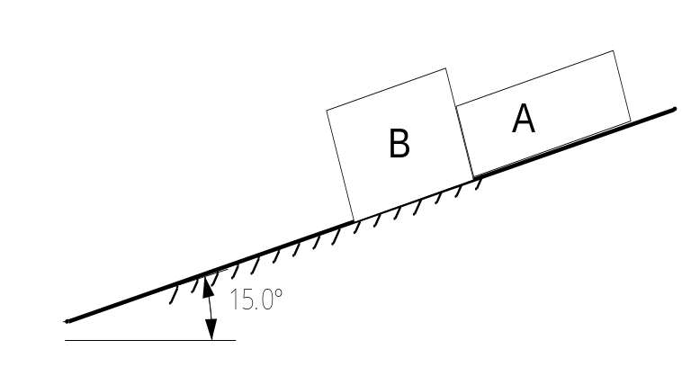 | 15
3. | A ballistic pendulum consists of a sand box weighing 5 kg that is suspended from a cord 3 m long. A 50 g shell is fired horizontally in the box and remains embedded in it. Because of impact, the sand box swings through a maximum angle 30°, as shown. Determine the height h and loss in energy of the system.  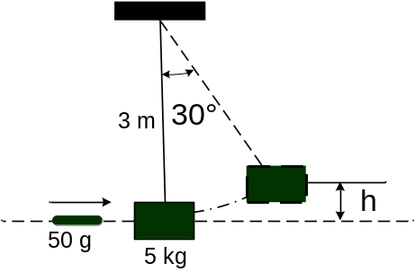 | 15
4. | A 240 kg space vehicle travelling with velocity V_{O} = 500 k m/s passes through the origin O at t = 0. Explosive charges then separate the vehicle into three parts A, B and C, of mass 40 kg, 80 kg and 120 kg respectively. Knowing that at t = 3 s the positions of three parts are, respectively, A (150, 150, 1350), B (375, 825, 2075) and C (-300, -600, 1200), where the coordinates are expressed in meters, that the velocity of C is V_{C} = -100 i -200 j + 400k m/s, and that the y component of the velocity of B is + 350 m/s, determine the velocity of part A.  OR  In a game of billiards, ball A is given an initial velocity V₀ along the longitudinal axis of the table. It hits ball B and then ball C, which are both at rest. Balls A and C are observed to hit the side of the table squarely at A’ and C’ respectively, and B is observed to hit the side obliquely at B’. Knowing that V₀ = 5 m/s, V_{A}= 2 m/s, and a=1.65 m, determine (a) the velocities V_{B} and V_{C} of balls B and C,(b) the point C’ where ball C hits the side of table. Assuming frictionless surface and perfectly elastic impacts.  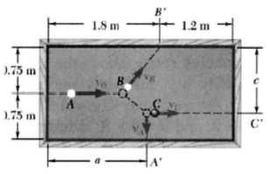 | 15
5. | The assembly shown consists of two rods and a rectangular plate BCDE which are welded together. The assembly rotates about the axis AB with a constant angular velocity of 10 rad/s. knowing that the rotation is counter clockwise as viewed from B, determine the velocity of corner E.  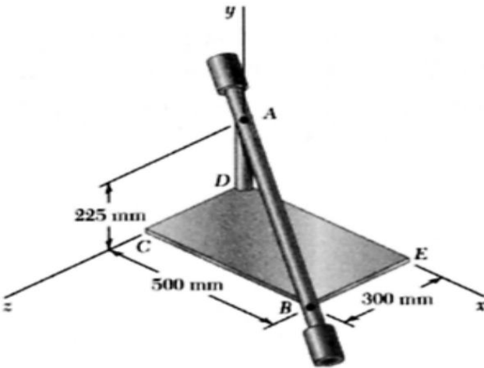 | 15
6. | A sphere of radius 100 cm and weight 20 N is release with no initial velocity on the incline and rolls without slipping. Determine (a) minimum value of coefficient of static friction (b) velocity of center G of the sphere after the sphere has rolled 5m.  30⁰  G  30⁰  G | 15
7. | Write short notes on (Any Two)  - Radial and Transverse component of acceleration  - Angular momentum  - Rotational motional | 5x2

